Azure AI Fundamentals AI-900

Predictions Vs Forecast

Prediction is a kind of estimation before occurrence of event.

A forecast, unlike prediction, must have a logic to it.

ML->foundation to AI system.

Relationship found in the data

Train machine learning Models.

Make predictions and inferences.

Forecast vs Prediction

Difference is the explicit addition of time element

Forecast is scientific, free from intuition and personal bias.

Prediction is subjective and fatalistic in nature.

Forecasting is extrapolation of past while prediction Is judgmental

Forecasting utilized in predicting weather, Prediction is utilized in economics.

Forecasting and Predictive Modelling

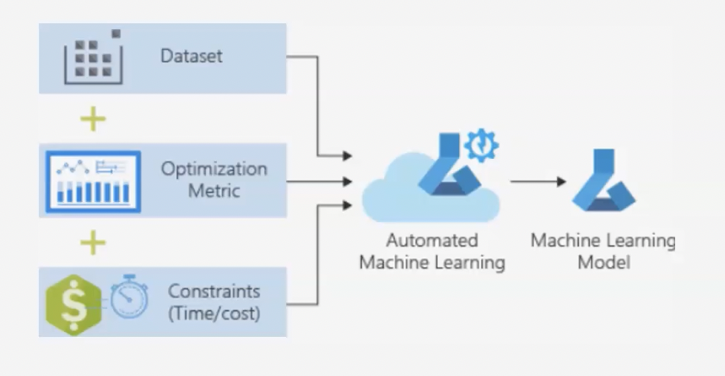

Tools to address data challenges.

Forecasting and predictive modelling

Data mining and probability to forecasting.

AML algorithm like Decision jungles.

Forecasting and predictive modelling sounds similar while both are different.

Predictive data modelling is a form of AI that uses data mining and probability to forecast and estimate more granular and specific outcomes.

Azure machine learning features a palette of modules to build a predictive model including state of art machine learning algorithms such a scalable boosted decision tree,Bayesian recommended systems, deep neural networks and decision jungles.

Features of Anomaly detection

Anomaly detection: - it is a machine learning techniques that analyzes data over time and identify unusual changes.

Anomaly detections aims at unexpected events on rare items in the data.

Accurate Anomaly Detection prompts to trouble shooting that helps to revenue loss and brand reputation.

Automatically detect anomalies throughout your time series data.

Detect anomalies throughout dataset in real time

Detect anomalies throughout dataset as a batch

Detect change points throughout dataset as a batch.

Get additional information about dataset.

Adjust anomaly detection boundaries.

Features of Computer Vision

After We have created a suitable azure subscription, we can use Azure Computer vision you can submit images to Vision Service in order to perform a wide range of analytical task.

1. Azure Computer vision can Describe an Image.

Use Azure Computer Vision in order to perform a Wide range of analytical tasks based on Images.

1. Tag Visual Features

Image descriptions generated by Computer Vision are based on a set of recognizable objects which can be used to suggest tags on image.

So that after that we can search images with specific attributes.

1. Detect Objects

The objects detection capability is similar to tagging the service a=can identify common objects, this service can also return bounding box co-ordinate.

1. Detect brands

Computer Vision Features also provide the ability to identify commercial brands

1. Extract Text

Features of Natural Language Processing

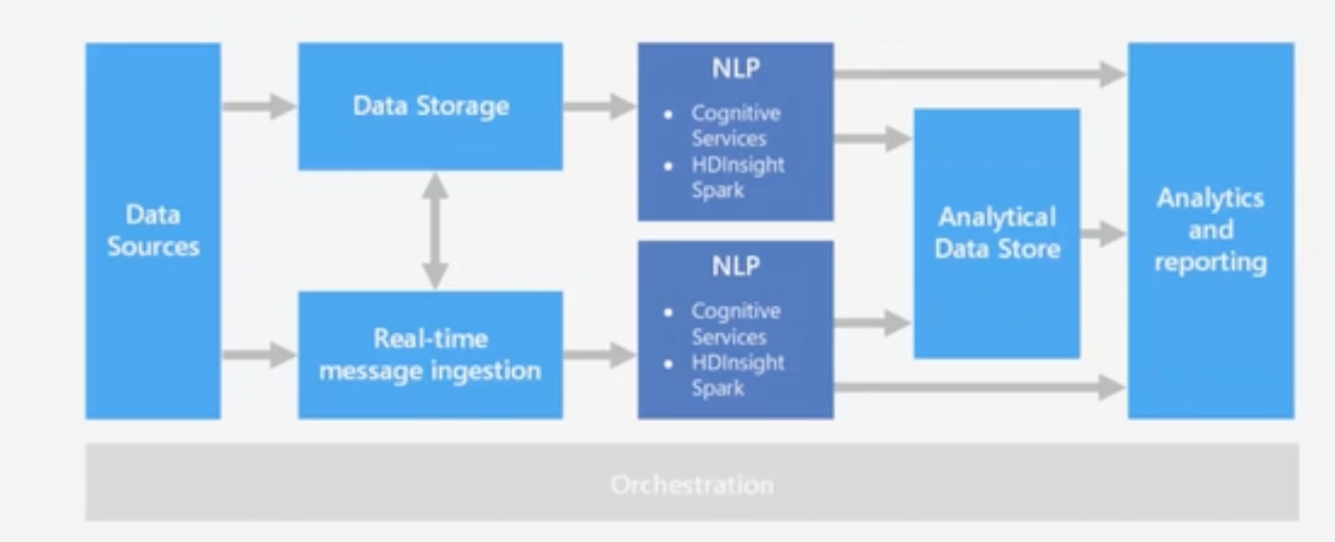

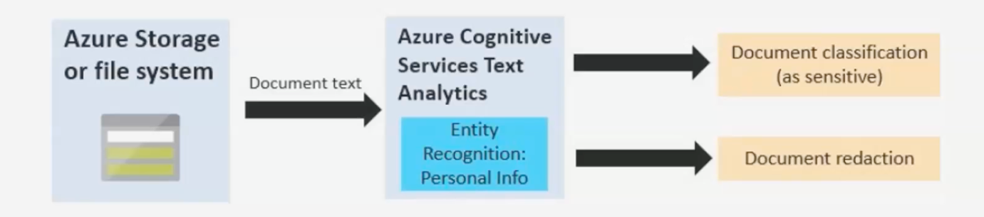

NLP can be used to Classify Documents such as Sensitive Documents or Spam documents etc.

Key Features of NLP are:

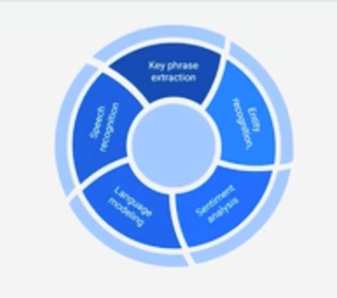

Key Phrase Extraction

Entity Recognition

Sentimental Analysis

Language Modelling

Speech Recognition

Uses of NLP

Classify Documents

Summarize the text

Search and Retrieval

Score Test Sentiment

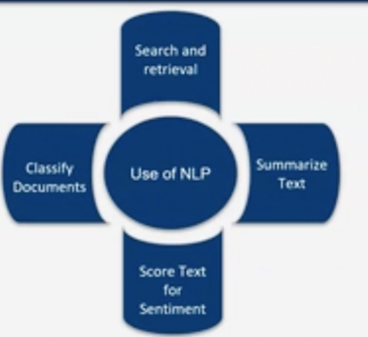

Following Azure Services Provides NLP services

Microsoft HDInsights with Spark

Microsoft Cognitive Services

Azure Databricks

NLP service in Azure-Ask Yourself

Do you want to use prebuilt Models?

Do you need to train custom models against large datasets

Do you need Low-level NLP capabilities?

Do you need simple, high-level NLP capabilities?

Features of Conversational AI

Azure Bot service

Microsoft Healthcare BOT

Customizable

For healthcare bot

To create conversational AI solutions, we can use

QnA maker Service

Web Bot Service

QnA maker is a cognitive service

That helps us quickly build the base of Knowledge and answers that can form the basis of AI agent.

Web Bot service provides us a platform for Creating, publishing and managing bot services.

Fairness in AI solution:

Six principles of AI solution

Trust is core of AI services.

Types of Harm by Ai systems

Unfair behavior of an AI system

Harm of Allocation

Harm of Quality of service

Reliability and Safety in AI

Automation Bias

Shortcoming in AI

AI automation in healthcare Systems.

Unexpected failures of AI models can be critical

Training vs Execution environment mismatch

Shortcoming in AI systems affect reliability.

The errors can be

“Known” Unknow

“Unknown” Unknown

Privacy and Security in AI

Large datasets with personal details like names

Data subjects to privacy or security concerns

Technical measures for protecting privacy

Techniques using suppression and aggregation

Traditionally researchers used to train the raw data where confidential data may get leaked.

But now

And still MS is working for more safety and security of data.

Inclusiveness in AI

Empower and engage everyone

Benefits to all parts of society

Inclusive design tools and processes

Expanded to areas of exclusion

Categorized of AI biased

Transparency in AI

Interpretability or intelligibility

Purpose and limitation of the system

Mitigation of Unfairness

Gaining trust from users.

Unfairness and trust lead to more usable products

ML systems make it easier identify and fix bugs

Design and evaluate methods to achieve intelligibility

Make existing intelligibility tools more useable

InterpretML

Open source package that tells us

Why did my model make this mistake?

Does my model discriminate?

How can I understand and trust the model’s decisions?

Does my model satisfy legal requirements?

Accountability in AI solution

AI designer accountable for how their systems operate

Work within frameworks organizational principles

Clearly defined policies and procedures

Designer & developer responsible to understand policies

Communicate guidelines with the users and partner

Periodic reviews and offline evaluation.

Machine Learning Algorithms

Find meaning in Complex datasets

Goal of ML => Discover patterns & make predictions

Answer complex questions

Regression & Classification algorithms

Supervised Machine Learning

Algorithms make prediction based on set of labels

Know what the outcome should look like

Regression and Classification Algorithms

Examples of Supervised Learning Algorithms

Population of a city estimation

Unsupervised Machine Learning

The data points are not labeled

Algorithm organized the data

Do not know what the outcome should look like

Clustering Algorithm example of unsupervised learning

Regression

Example of Supervised ML.

Classification Model in machine learning

Classification model, example of supervised learning.

Draw conclusion from observed values

Uses known labels to train the model

Predict labels for new items where unknown.

Logistic Regression

Azure Machine Learning designer for models

Regression outputs a numerical value

Classification is applied to data with binary output

Decision forgets and logistic regression are examples

Decision forest are fast and supervised and assembled models.

They produce better results and in a more generalized model by creating multiple models and combining them in some way.

Generally, ensemble models provide better accuracy than simple decision trees.

This model is a good choice if we want to predict a target with maximum of 2 outcomes.

Clustering in machine Learning

Grouping data points into similar clusters

Clustering, example of unsupervised learning

Customers who like similar products

Useful first step in discovering new patterns

Also known as segmentation

Used with data that is not labelled.

Grouping useful in making predictions

**k-means**, best known unsupervised algorithm

Label column in optional in k-means

Centroid, a point representative of each cluster

We specify number of centroid for the Clusters.

Features and labels in a dataset for machine learning

Storage Service & Databases in Azure

Abstraction layer for underlying storage service.

Mount it on compute target consume it directly.

Azure ML datastores secure connection

Storage Service in Azure like Azure Blob container.

Datasets are not copies of the data.

Reference to the data with the copy of its metadata.

Reuse it across different experiments

Types of datasets: Filedataset and Tabulardataset

Features and Labels

Features, independent variables that acts as input

Labels are the final output

Trained models get “features” as input

Return the predicted “label”

Data drift

Removal of feature from the dataset

Central location to manage and monitor labelling

Input data leads to model performance degradation

Monitoring data drifts detects performance issues

Information on features responsible for data drift

Training and Validation datasets in machine learning

Training and Validation Datasets

Biased score on training dataset only

Set of samples for evaluation of the final model

Training dataset, sample of data used to fit the model

Validation dataset, sample of data used to fit the model

Cross Validate Module

Dataset divided into number of subsets called folds.

Compare accuracy and interpret quality of dataset

Trains and validates the model multiple times

Normalize datasets before using for cross validation

Computationally intense

Machine Learning Algorithms & Techniques

Supervised Machine Learning

Unsupervised Machine Learning